Releasing Destiny World Wide Ministry update 10-2-18

Praise the Lord! I traveled well to get to Kenya.  On the first long flight I sat next to a man who works internationally to improve operations in large hotels.  It was very interesting to hear him share how he integrated his Christian faith with the work that he does.  I could see that God was using him on the business mountain in an amazing way.

On the second long flight, a man sat next to me and began talking.  I learned that he was working for the President of Kenya in the State House as an IT Engineer.  He also was on the Atomic Energy Commission.  I began to share with him about Charlie Shamp’s accurate prophecy for Kenya before the last election and that he will hold a meeting there in November.  I suggested he consider going.  He shared he is “not into that kind of thing much” as he is Seventh Day Adventist.  I encouraged him that he might find it of great interest and later was able to send him the poster for the meeting.  Before we got off the plane, he gave me his phone number and said that if I had any trouble when I was in the country with customs or the police or anything I was to call him.  He said that since he started working in the State House he finds that he can just make a few phone calls and has noticed an increased authority to get things done quickly (Praise the Lord!)  He then proceeded to tell me that he was not scheduled to sit in that seat, but that his brother convinced him that he should move closer to the front of the plane so that is how the DIVINE APPOINTMENT came to be!

I arrived well in Nairobi, Kenya on 2 of September.  I stayed at Mayfield Guest House and they sent a van to pick me up at the airport.  This is a missionary guest house sponsored by Africa Inland Church.  I met several other missionaries working in Kenya and Chad Africa.  I learned many helpful things from them. The next day I went to Immigration to pick up my Alien Id card and that went without any problems, so I scheduled a bus for the next morning to take me on the 8-hour journey to Busia where I will be living.  My landlord has a car and he was at the bus station to pick me up.

I have been incredibly busy getting the two apartments (side by side) equipped with the necessary things.  I still have a few things to complete.  I ordered curtains yesterday and need to get the rods for hanging them.  Triple and double decker beds are being made for pastors who come from far and stay here.  I hope to have room for 12 to sleep in one large room in the second apartment.  There is another bedroom there for visitors from USA as well that has a lower double bed bunk and upper single bed.  Equipping these apartments has been incredibly expensive.  If you feel inclined to contribute some support, find a information and a link at the bottom of the message explaining how you can contribute.

My landlord has a sweet cat and it loves me and I love it, but I believe it has fleas – I have bites on my ankles and feet – so itchy – I used to get flea bites when we had cats at home, so I am remembering how that was.  Still trying to figure out how to deal with that.  We have sprayed the houses against mosquitoes and the yard is also supposed to be sprayed soon.

So far, I have had the first class, 4 Keys to Hearing God’s Voice, with 16 students.  More had hoped to come, but about 5 were not able to make it. The class went very well and there were 3 students that slept in the second apartment.  My landlady used to have a restaurant and she along with her friend did the cooking for us those three days.  I have not completely calculated the cost, but it was more than I expected, however we do have some supplies left over that should work for the second class coming up on 8, 9, 10th of October.  There were good testimonies here too and I will see if I can post On One Drive with a link for those of you who are interested  <https://1drv.ms/f/s!AvULpVZU-LYNhb9SrIKw2iE-qojI_g> .    Here are some of the students and our lunch room.

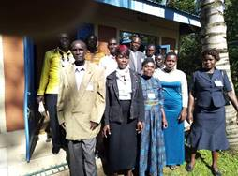                             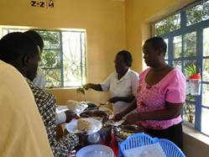

I also have done a 3-day conference in another city.  This was very powerful as there were so many great testimonies of forgiveness and deliverance.  I am going to see if there is a way to post these on One Drive and supply a link  <https://1drv.ms/f/s!AvULpVZU-LYNhb9PMNT9TAfbxMjdDw> .  The host of this conference has 60 orphans that he cares for and he is in need of lots of financial support.  He has such compassion for these children but has great needs for bedding, clothes, food, shoes etc.

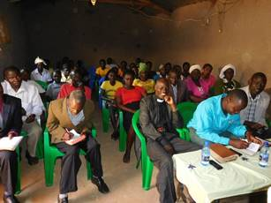           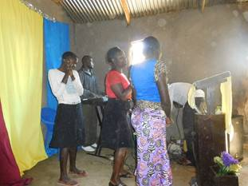

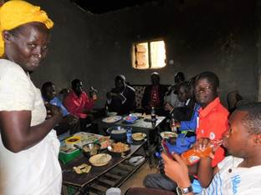      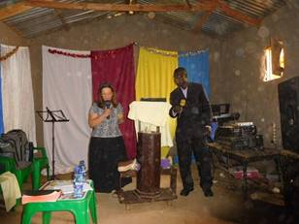

I have also had some inner healing appointments and have more scheduled.  One pastor was very leery at first but left rejoicing after we did the repentance and recommitment prayer leading to deliverance.  I am to see his wife this week – please pray for this as she is reportedly considering suicide due to the pain she has from arthritis.

One of the pastors brought me so many bananas.  I estimated that there might have been 50.  These were green and did not ripen until the day after the students left.  So, I gave some away and ate some and started making banana bread with them in my toaster oven.  Well they were all ripe and I had to leave for 5 days for the conference, so I put them in the fridge.  Made some more banana bread and more banana bread when I came back.  Still there were many bananas so today I counted the remaining – there were still 60 very ripe bananas, so I put them in groups of three and mashed them and put in little packets in my freezer – hoping I can take them out and still make more banana bread but so not as to overdose on it! It seems I have enough for 18 more batches (wow)!

I turned 65 on the 29 of September.  One young girl who I have sponsored for her schooling brought me a surprise cake and birthday hat.  Later I invited my landlord and his family over for – you guessed it – banana bread cake.

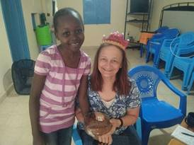                         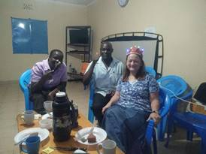

Electricity is off and on here – I had hoped to use the TV to show the videos, but thankfully have the small projector and big screen that run on batteries, so we were able to watch all the videos of Dr. Mark Virkler teaching and complete the class well.

Cliff Dyrud will be joining the work here in late October.  Part of the three months he is here he will travel to some places in Uganda where we have been ministering in the past.

Jealousy is a really big problem here as well as unforgiveness.  Human life does not carry much value here, so it seems easy for people to plan murder.  This is something I have known over many years of coming here as many have publicly testified after the forgiveness exercise that they were planning to kill someone.   The false gospel of “prosperity” is here, and people run after miracles to many different places. Many people do not have Bibles to be able to discern the truth of what they are being taught.  Witchcraft and ancestor worship is very real and still affects almost every person who has become a Christian, often because of rituals done to them in childhood such as circumcision, naming, dedications to the enemy that have not been cancelled.  The prayer we use has yielded many amazing results.  Many pastors use this prayer after we leave.  Here is one recent testimony.

“I was in lira and I led a boy through the repentance prayer and immediately he testified that it was delivered

The boy was being attacked by some demonic forces that cannot allow him to read and yet is a student

But after prayer with him he said he felt something like fire was behind him and as if I was I’m untying something out of his head. After the prayer you could read without any pain though he still says that he feel some something like it’s moving on his umbilical cord but I told him to continue to believe for total healing.”

I was able to give him some suggestions when he does follow up to be sure that this other manifestation also leaves.

Please continue to pray for the work here and for me to remain strong and healthy.  If you are led to contribute to the efforts here, please find the following information describing how you may do that:

If you do not need tax deductibility for your contribution for my trip expenses and the work here, write your check out to me, Pauline Burthwick and send it to Judy Balluff, 1008 33rd Street S., Moorhead, MN 56560. Judy will record the gift in our records and then deposit it in my bank account. (She will do likewise for checks to Cliff Dyrud.)

If you would like to make a tax deductible contribution to support the work of Releasing Destiny World Wide, you may specify if your contribution is for Pauline’s or Cliff’s expenses.

1) you may contribute by Papal by using this link

<https://www.paypal.com/cgi-bin/webscr?cmd=_s-xclick&hosted_button_id=AAYU4Q8D6KEYU>

or 2) for donations by check, **Make checks out to Releasing Destiny World Wide and mail to**

Visions Made Viable, 17595 Harvard Ave, Suite C235, Irvine, CA, 92614

You should include your mail address so that you will receive a contribution receipt from Visions Made Viable.  Please keep all of those receipts as they only send them out at the time of the donation and not at the end of the year.

Blessings to all of you – Hope to be home Mid-March

Pauline Burthwick

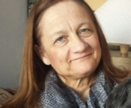

Minister Pauline Burthwick

Minister of the Gospel of the Kingdom to the Nations

Teaching, Counseling, Inner Healing & Deliverance Ministry

Certified Communion with God Facilitator - 4 Keys to Hearing God's Voice

[www.releasingdestinyworldwide.org](http://www.releasingdestinyworldwide.org/)

[www.cwgministries.org/certified/facilitators.htm](http://www.cwgministries.org/certified/facilitators.htm)



Releasing Destiny World Wide, 121 Walnut Way, Lebanon TN 37087 +1-701-371-7720

PO Box 523, Busia, Kenya 50400  +254 797 404 683 (September through March 16)

if you would like to make a tax deductible contribution to support the work of Releasing Destiny World Wide, you may contribute by PaPal or credit card by using this link

<https://www.paypal.com/cgi-bin/webscr?cmd=_s-xclick&hosted_button_id=AAYU4Q8D6KEYU>

or for donations by check

**Checks made out to Releasing Destiny World Wide**

mailed to

Visions Made Viable, 17595 Harvard Ave, Suite C235, Irvine, CA, 92614

Note: No portion of this email may be reproduced or altered in any way without the express consent of Pauline Burthwick.