Free Conference Call - Spirit Life Circle Meetings

How To for Participants

Begin by Downloading Free Conference Call (“FCC”) software
- Go to www.freeconferencecall.com. You will need a computer or other device with a working camera and microphone so you can be seen and heard on the video conference calls. It will walk you through the downloading and running of the software program by asking you for your email address and creating a password.
- Once you have your Desktop App downloaded to your laptop, you can test it by:
- Opening the app by clicking on the FCC icon on your computer. This FCC icon should now be found on your desktop and you can pin this to your start menu to make it more readily available.
- Open up the FCC app on your computer to make certain it loads. You will see a choice to click on either “Host” or “Join” an online meeting. As a Spirit Life Circle participant, you will choose “Join” and then fill in your name and email address and the meeting ID from your email invitation and click “Join” again.
- You should now see a floating toolbar somewhere on your screen, probably at or near the top.
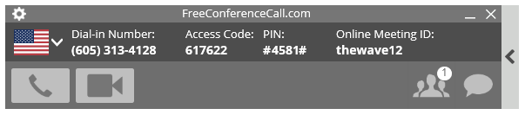
- If you see this toolbar, you are in the program correctly.

- To close the program, now or after your Spirit Life Circle conference calls, you can simply select the X in the upper right of the window the way you usually close a program. This will remove you from the meeting and close out the program. NOTE: Make certain you haven’t accidentally minimized this toolbar at the bottom of your screen…if you see it there, the program is still running.

Now you are set up and the program is working (above) so you can easily join a Spirit Life Circle meeting.
- When it is time for you to join your Spirit Life Circle meeting, you will have already received an email invitation from the host of your group with instructions as to the date and time and a link you can use to join the meeting. When you click on the link in the email invitation it will automatically open up the FCC app on your computer.
- When prompted you simply click on “Join”, and click on “Join”.

- Click on the camera icon to join by videoconference. Video is live once the Camera turns green. (You do not need to use the telephone icon. If you accidently click on the telephone receiver icon at the top of your screen during a meeting, it will disconnect your voice so you cannot be heard by others in the group. If you click on it again, it will reconnect you over the next 30 seconds.)
- You will be able to see everyone in the group at the same time if you have successfully downloaded the FCC app and made the connection through the app.
- While in the conference, you can double click on the large portion of the window to maximize the window to full-screen and double-click again to bring it back to a normal window size. If you want to minimize your conference call window, you can do that only from the normal screen, not while it is in full-screen mode.
- If you would like to send a chat message to the whole group or to an individual during the meeting, you can click on the “chat” icon to send your message.
- If you see the FreeConferenceCall toolbar on your screen but cannot see the video of everyone, you may have other windows open in front of the conference program while you’re in the meeting. To view everyone again you can select the FreeConferenceCall button on the bottom of your computer monitor to bring it back to the front and view it again. If it is not there, you are no longer in the program.
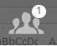
- If you need to mute yourself at any time during the conference, you can find the “mute” option under the list of attendees icon on the toolbar. Simply find your own name and locate the microphone icon on the right beside your name and select it. When you are muted there will be a line through the microphone so you know you will not be heard.
- If your computer has trouble connecting, you can join this session by phone (with audio only) and work on fixing the video issues at a later date. To join by phone simply call in with your own phone using the number listed in your email. Or you can find the number to call in from your own country by selecting the drop down arrow on the right of the Flag icon, upper left on the toolbar.
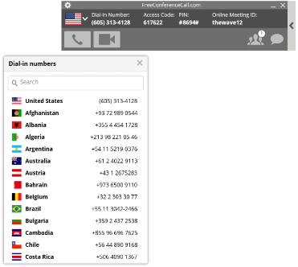

Practice this software by connecting with family and friends.
- For practicing with family or friends, send them an email invitation to join you for an online meeting. You will have to tell them in the email the date and time you will set the video conference call. To send the information in your email, log on as “Host”, select the icon at the top, right of the floating toolbar that looks like a person with a plus sign.
- This will give you a pop-up window that contains the information you will need for your invitation. Select “Copy to Clipboard” at the bottom of this window then you can paste it into your email along with your other information. This will give your participant(s) the link they will need to join you. (You can also select “Invite by Email if your email is set up to work with this program on your computer.)
- When it is time for your meeting with them, simply open the program and at log on choose “Host” instead of “Join” when prompted on your screen. When you are the host, the floating toolbar will look a little different than when you are a participant. Select the Camera icon again and you will be connected to the meeting. You do not have to be first for the others to join the meeting.
- Once you have set up a meeting and the meeting time has arrived, you as the host simply click on “camera icon” on the top of your screen, and the camera comes on, and you see yourself. This puts you in the chat room, so when your friends connect, through the app, you will see them and they will see you.
- Or perhaps connect with your group coach who can practice with you or provide a person whom you can practice with. This is a wonderful tool to assist you in cultivating friendships with those you love. Practice a couple of sessions and you will be ready to go.

Here are cool, short videos which give you an overview of how you can use this FCC app.
- Getting started video (90 seconds)
- How to Use Video Conferencing (1 minute video)
- How to Start a Q&A Session (1 minute video)

